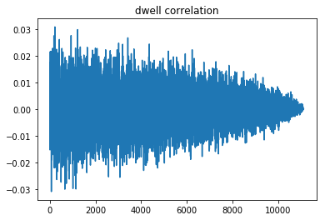Dwell time correlation with roughly 10k data points:

Power Spectrum averaged over 10 trials with nt = 200,000, delta = 0.001, c = 0.01:

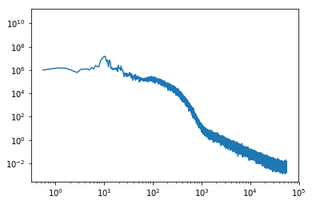

Dwell time modified histogram, 5 datapoint per bin minimum (not enough data!):

